TOPIC/TITLE

Keywords/Questions  syntax  ressources  Syntax  Best practices  String  Data type  typeof | Notes :
You can write some JS code in th console from the chromes’s inspector
Alert(“hello”);
 | You can also go in sources (nest tab)
 | Click on the double arrow in the top left corner and choose snippet then new snippet
 | Go to MDN JS
 | alert(“hello”);
 | 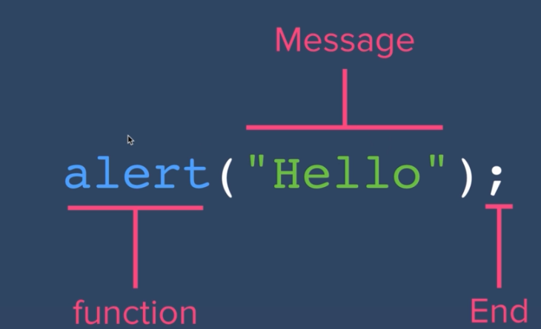
 | It is better to to put space in code. It is making the code more uniform with other programmeurs.
 | Simple quotes or double quotes makes no difference for the computer but as a style convention, double quotes is prefered(for quotes word or piece of texts) except some cases we will see later.
 | https://github.com/rwaldron/idiomatic.js/
 | Elements not to be interpreted as code.
 | Way of classify data to tell the computer how the prgram intend to use the data
String : “text”
Numbers
Boolean : true or false
Will tell which data type is
eg : typeof(2358);
=number

